**Sprint 3 Plan**

**Product:** GoLift

**Team Name:** Team Squat Squad

**Release Name:** Release 2

**Sprint Completion Date:** July 26

Revision One

**Revision Date:** July 18

**Goal:** Put the finishing touches on the app, work on fixing the design, and making it look nicer.

**Tasks:**

*As someone who does not use a lot of technology, I want an easy to use app.*

Work on making app more user-friendly (2 hours)

*As a person that has never worked out before, I would like suggestions on what would help.*

Implement quiz (1 hour)

Implement research (1 hour)

*As a person that tends to choose apps based on how they look, I want an application that is aesthetically pleasing.*

Choose final layout of app (1 hour)

Implement final layout (3 hours)

Make an app that is pleasing to the eyes (2 hours)

**Team Roles:**

Merrick Swaffar: (Product Manager)

Nishika Tripathi: (Scrum Master)

Siobhán O’Shea: (Scrum Master)

Jenna Wu: (Team - designer)

Peyton Fonck: (Team - developer)

**Initial Task Assignment:**

Merrick Swaffar: As someone who does not use a lot of technology, I want an easy to use app. Work on making app more user-friendly (2 hours)

As a person that tends to choose apps based on how they look, I want an application that is aesthetically pleasing. Implement final layout (3 hours), Make an app that is pleasing to the eyes (2 hours)

Nishika Tripathi: As a person that has never worked out before, I would like suggestions on what would help. Implement quiz (1 hour), Implement research (1 hour)

Siobhán O’Shea: As a person that has never worked out before, I would like suggestions on what would help. Implement quiz (1 hour) Implement research (1 hour)

Jenna Wu: As a person that has never worked out before, I would like suggestions on what would help.Implement quiz (1 hour), Implement research (1 hour)

Peyton Fonck: As someone who does not use a lot of technology, I want an easy to use app. Work on making app more user-friendly (2 hours)

As a person that tends to choose apps based on how they look, I want an application that is aesthetically pleasing. Implement final layout (3 hours), Make an app that is pleasing to the eyes (2 hours)

**Initial Burnup Chart:**

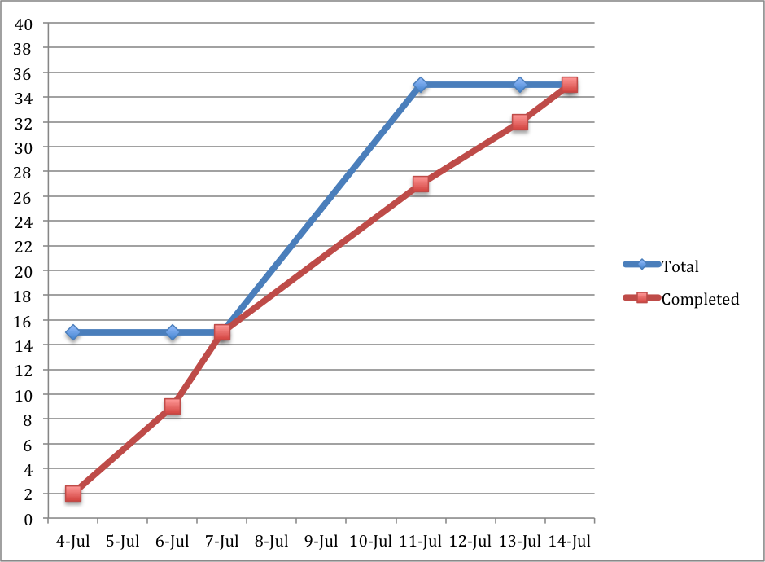

**Initial Scrum Board**

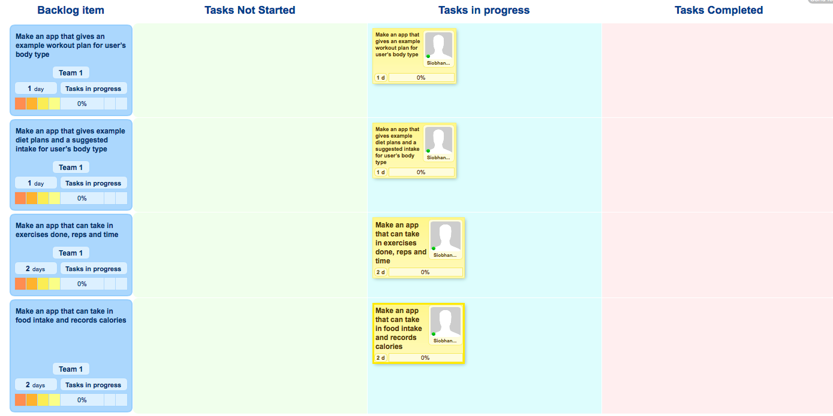

**Scrum Times**

Monday 4:30

Wednesday 4:30

Thursday 12:30